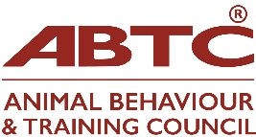
Name:
If you are interested in joining ABTC’s Board of Trustees, would you please detail experience of any of the below.
Skill/Experience/Knowledge | Tick/ check | Details
Accountancy
Animal welfare
Animal practitioner
Assessing (Practitioners)
Business Analysis
Business Management
Campaigning
Charity Trustee
Content Creation
Data Analysis and research
Education
Electronic communication
Event organisation
Fundraising
Governance & Regulation
Human Resources
Legal
Lived Experience eg DEI
Lobbying to government bodies, links to MPs
Marketing
Media/PR
Networking
Peer-review process
Process Design
Social-Media
Technology eg video editing, Artificial Intelligence
Veterinary
Volunteer Manager
Dogs
Cats
Equids
Small mammals
Birds
Domestic Livestock
Non-traditional companion animals
Zoo animals

Application continued on next page
Application, continued
Do you have anything you wish to contribute to the Board of Trustees not mentioned above either in terms of experience, knowledge or skills?

Please feel free to attach further notes or a CV detailing your experience. These will be shared with ABTC Members and Trustees for voting purposes.

If you have any questions, please email the Trustees via admin@abtc.org.uk

Signed:
Date:

PLEASE RETURN THIS COMPLETED FORM TO admin@abtc.org.uk BY 7 May 2026

THANK YOU

