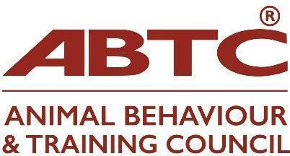 | Sponsorship  Application Form

Thank you for your interest in becoming an ABTC Sponsor.

Animal Behaviour and Training Council sponsorship is open to individuals and organisations who support the ABTC goals and ethos. We are fortunate to have many organisations who align with our values and have an interest in training and behaviour of kept animals, but who are not an organisation who assesses or registers assessed practitioners, nor are charities concerned with the welfare of animals. Sponsorship is an excellent way to demonstrate that your/your organisation’s support for the principles of ABTC’s approach, and demonstrate your commitment to this approach in your work.

Please take a look at the Sponsorship pack for further detail.

We look forward to welcoming you as an ABTC Sponsor.

Sponsorship fees for 2026:
Sponsorship Category Annual fees
Standard Sponsor £50
Bronze Sponsor £250
Silver Sponsor £500
Gold Sponsor £1000
Platinum Sponsor £5000

Criteria for sponsorship are:
- Sponsors must be committed to the aims of the ABTC
- Sponsors must reflect ABTC values and approaches in their work

Organisation – contact details
Name of organisation
Website address
Name of contact: |  | Email
Telephone
Postal address
Second Contact |  | Email

I/our organisation would like to apply for the following 12 month’s sponsorship
Platinum Sponsorship - £5000
Gold Sponsorship - £1000
Silver Sponsorship - £500
Bronze Sponsorship - £250
Standard Sponsorship - £50

Yes/No | Please type ‘yes’ or ‘no’ in the left-hand box to let us know your choices
 | When accepted I would like my/my organisations name to be listed on the ABTC Website
 | When accepted I would like my logo and website to be shared on the ABTC Website

Declaration from Sponsor
We commit to:
- Supporting the charitable aims of ABTC.
- Supporting and promoting the ABTC vision of regulation of the animal behaviour and training industry.
We confirm that:
- We will not act in a manner that may be detrimental to the ABTC
- We agree to be subject to the ABTC disciplinary procedures

Signature | Date
Full name and – if appropriate - role in your organisation:

Applications should be accompanied by a non-refundable application fee of £10.00 (details below). On acceptance, an annual sponsorship fee (details above) becomes payable

Please return this form to admin@abtc.co.uk
Please transfer your non-refundable deposit to:
Animal Behaviour & Training Council
Sort code: 30-92-79
Account no. 28617368

Please include reference to your name or that of your organisation and send remittance advice to treasurer@abtc.org.uk

