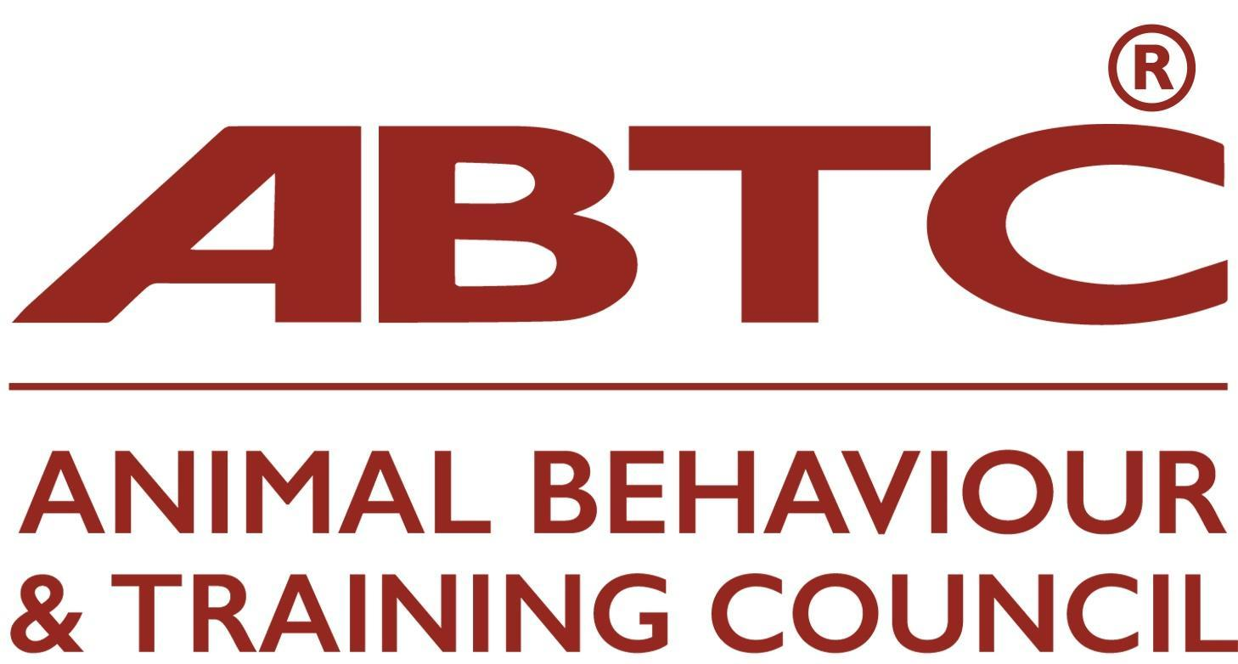

Application for ABTC Recognition of Programme: CV Proforma for Staff involved in Teaching and/or Assessment

Please complete ALL sections (A - F), stating Not Applicable as relevant.
Please provide copies of supporting documentation such as qualification and CPD certificates

Date of completion:

- Contact Details

Name:

Address:

Country:

Phone:

E-mail:

- Area of teaching responsibility on the programme (module, subjects and/or LO number):

- Academic Qualifications including any teacher training / mentoring qualifications

Subject | Institution | Date of qualification | Degree | Postgraduate

- Practical/Industrial qualifications eg BHS or BIPDT. Please give level attained

Qualification name | level | Institution | Date obtained

- Industry Experience
Please provide a brief overview of your relevant industry experience: how long you have worked in the field, in what type of establishment, and roles undertaken.

- Continuing Professional Development (CPD)

CPD attended in the last three years: This should include CPD both external to and within the Learning Provider organisation

CPD subject | Organising body | Length (hours) | Date

- Criminal Convictions

I confirm I have no criminal convictions that are relevant to me owning or working with animals or with vulnerable people, including children and older adults.

(where appropriate, please include a copy of Disclosure and Barring Service Check).

Signature Date

- Declaration

To the best of my knowledge the information given herein is correct and I agree to abide by the ABTC Code of Practice with respect to my teaching and practice.

Signature Date

