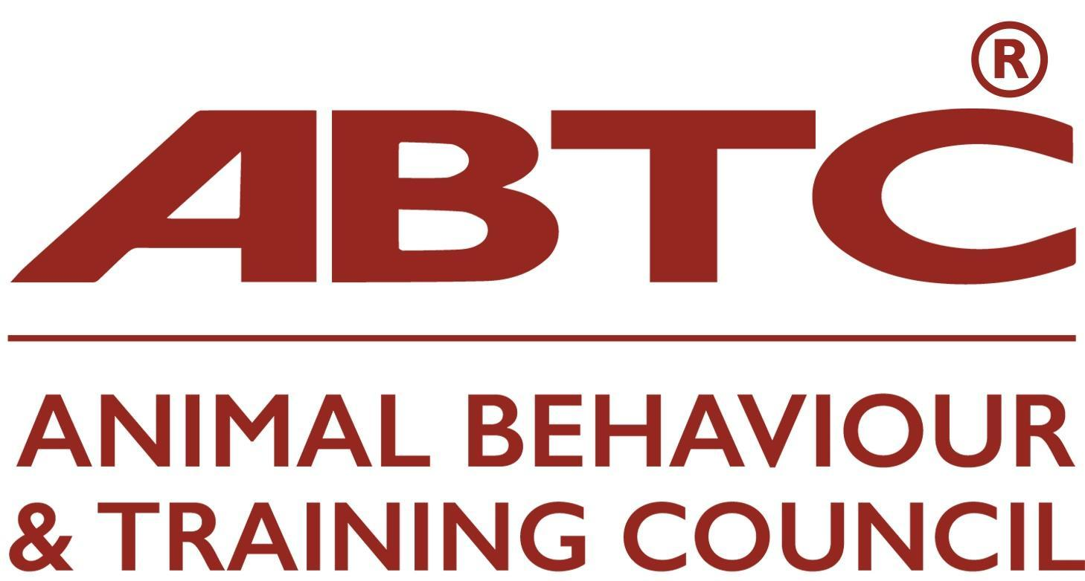

Course Recognition Procedure

Programme Recognition Application Guidance Notes
All documentation provided to the ABTC Programme Recognition Committee (PRC) will be kept and used in accordance with the UK Data Protection Act 2018. The ABTC will process this information for any/all of the following purposes: accounts and records; realising the objectives of a charitable organisation; advertising, marketing and public relations; consultancy and advisory services; education; research, and may be passed onto ABTC group companies, government agencies and bodies.

Applications will be acknowledged within three working days of receipt (if you don’t hear from us, please assume it has not arrived) and will be passed to the Programme Recognition Committee who will schedule a review. The first stage will be for PRC to meet and assign assessors to the project. Then those assessors will check that all relevant documents have been submitted, eg CVs etc. However, later when the assigned Assessors are undertaking a detailed review for recognition, some further omissions may become apparent and the PRC Assessor or the ABTC Assessments Administrator will contact you to liaise for this to be provided. Please note that the omission of documents may delay the recognition of an application. The PRC Assessors will aim to conduct a detailed review and provide initial feedback within eight weeks of you applying.

PRC Assessors may contact you prior to this with any questions they have regarding your application. Please note it may take a further four weeks in cases of minor changes for the applicant to amend their application for further review. The aim is for reviews, any required modifications and completion of the recognition process to occur within a 3 month period.

Documentation should be provided in electronic format – word/excel/open document format, please. All documents should be clearly numbered and named, and a full index provided.

Pre-submission support
Support for providers can be given pre-submission and will consist of an online meeting totalling up to four hours with a member of the PRC. The fee for this meeting will be £100.

Outcome
Successful recognition will be notified to the course provider via email. A programme that has been formally recognised by the ABTC scheme can be described as an ‘ABTC Recognised Programme’. The following statement can be included in publicity material: ‘This programme has been formally recognised by the ABTC Programme Recognition Committee as delivering the academic elements necessary for an individual to achieve ABTC recognition for the Knowledge and Understanding of a [relevant ABTC role]’. Once recognised the programme will be entitled to display the ‘ABTC Recognised Programme’ logo on their certification.

Individuals who achieve an ABTC recognised programme for a particular ABTC role will have fulfilled the Knowledge and Understanding requirements of ABTC Practitioner Organisations for that role.

The Programme Recognition Committee will contact programme organisers and provide a written report of any concerns that the Committee may have or alterations that are required. If desired, further guidance on how these can be met will be provided by online meetings. Where changes are minor, this will be considered as part of the submission process.

If the discrepancies between the ABTC standards and the programme submitted are of a sufficient extent that recognition cannot occur then resubmission will be required. We would recommend that if you wish to re-submit you utilise the pre-submission support as discussed above.

On completion of the review by PRC the balance of fees will be due, whatever the outcome. If the programme has been recognised by ABTC the logo, and permission to note it as ‘recognised’, will be given.

Programme recognition continuation.
Each year an annual report is required and at the end of year five a full programme review is conducted (please also see ‘Full programme reviews, below)

Any changes to a programme during the intervening period should be submitted to the ABTC Programme Recognition Committee as soon as possible or within two months, whichever is the sooner, of the change occurring. This includes changes to the teaching and assessment team. Any changes that may implicate the meeting of the ABTC learning outcomes should be discussed with the ABTC Programme Recognition Committee before implementation to ensure ABTC recognition can continue.

ABTC approval only recognises the content of the programme at the time of initial application, or continuation review, to the ABTC. Such recognition does not provide any guarantee that any learning provider is financially viable or that the standard of the content has remained the same standard as when it was assessed by the ABTC.

Operation of the programme other than the content is not the responsibility of the ABTC.

Annual review
Organisers of each ABTC Recognised Course are required to submit a short annual report by 1 October (unless otherwise stated) confirming that ABTC requirements for recognition are being adhered to. Where documentation has been changed, these changes must be clearly indicated through tracked changes. You will be contacted in September each year by the Assessments Administrator with a form to complete outlining the deadline to reply and an invoice will be attached for the amount outlined below under ‘costs’.

Programme organisers will be informed of the outcome of their annual review and be told if the following year will be an annual review or a full programme review.

Full programme reviews

Full programme review will be every five years. However, if there are changes to the standard for which your course has been recognised (role standard reviews are every three years) then the programme will need to be reviewed earlier.

Full reviews will require organisers to resubmit all paperwork by the deadline given when we notify you. Within two months of this deadline, programme organisers need to inform if continuation of recognition is being sought. They should be aware that this may require a new application being submitted, for example, if there have been substantial changes to the programme in the intervening period.

Contact details and costs:

Programme providers wishing to find out more about the requirements for recognition and the application process can obtain further information by contacting the Chair of the Programme Recognition Committee, (please email via assessments@abtc.org.uk). Application forms can be downloaded from our website: https://abtc.org.uk/education/ - see ‘ABTC Programme recognition application form.’.

The ABTC Programme Recognition Committee is a non-profit-making venture. It is required to be economically self-supporting. Applications for programme recognition require a non-refundable fee, regardless of outcome. A further fee will be due at the time of continuation review, every three years.

Programme Recognition Application:

Initial Full Review:
£1030 for a course/programme up to 60 credits
£1360 for a course/programme up to 120 credits
£1690 for a course/programme up to 240 credits
£2020 for a course/programme up to 360 credits

This fee is non-refundable irrespective of the Programme Recognition Committee’s decision. An Initial invoice will be issued for 50% of this fee on receipt of the application. The remainder of the fee will be payable when PRC has reached their decision.

Annual Renewal Fee = £300
Five-yearly Review Fee = £870

Non-UK based Education Providers
Online courses that are aimed at UK practitioners will be considered for recognition providing that the course materials and student’s work are submitted in English and that the course
provider is accredited by a recognised regulatory body.

Thus, international courses will only be considered for recognition if they offer a distance learning option that meets the above requirements.

If a course provider has any questions, for example, if an element of the course requires face to face contact, the ABTC Programme Recognition Committee will be happy to discuss.

Section A: Glossary of Terms

- Programme refers to one or more units that are intended to meet all or part of the ‘Knowledge & Understanding’ requirements for an ABTC defined ROLE.

- ABTC defined Roles are
  - Animal Trainer Level 3
  - Animal Training Instructor Level 4
  - Animal Behaviour Technician Level 5
  - Clinical Animal Behaviourist Level 6

- These have specific Knowledge and Understanding requirements (Learning Outcomes) at particular levels. These are given in the Standards for Practitioners of Animal Training and Behaviour. Please refer to https://abtc.org.uk/practitioners-info/.
- Levels are defined in the National Qualifications Framework and relate to increasing levels of depth of knowledge, ability to synthesise and critically assess information. Please see section B below on NQF.

- A Learning Outcome is formally assessed at the required level for the role.

For example:

Learning Outcome: to show knowledge and understanding of the Process of extinction in operant conditioning.

This could be assessed at different levels as follows:

Level 3 (Animal Trainer): Describe the process of extinction in operant conditioning.

Level 4 (Animal Training Instructor): Discuss the relationship between extinction and reinforcer contiguity and contingency in operant conditioning.

Level 5 (Animal Behaviour Technician): For a given problem behaviour, such as jumping up at people, evaluate how resistance to extinction is implicated in its development and analyse the use of positive punishment and positive reinforcement methods to prevent the development of this behaviour.

Level 6 (Clinical Animal Behaviourist): For a given problem behaviour, such as jumping up at people, describe one possible aetiology and critically compare the use of Differential Reinforcement of Other (DRO) schedules or Extinction schedules as behaviour modification tools. This should include consideration of learning theory and physiological, behavioural and psychological consequences.

- Learning outcomes have been logically clumped into ABTC Modules which may directly relate to the Applicant’s Units. ABTC modules have Credit value associated with them.

- Credit value indicates the size of the course/unit and how long it typically takes to achieve. One credit represents 10 hours of learning. These hours will be made up of Guided Learning and Self-directed study. Thus a 15-credit module is expected to take a typical learner 150 hours to gain the required level of knowledge and understanding.

- Guided learning activities include face-to-face lectures, tutorials and practical sessions, online discussion forums.

- Self-directed learning activities include individual research and reading, preparing individual or group assessments.

- Please note that it is expected that those teaching and/or assessing on a programme will be qualified at least one level above the students they are teaching/assessing in the subject area and have relevant applied and/or research experience, as appropriate to the subject matter. Evidence of this should be provided in the individual tutor’s CV.

- For Programmes at Level 5 and 6, Animal Behaviour Technician and Clinical Animal Behaviourist, the teaching of clinical procedures will be expected to be provided by those who have demonstrable relevant clinical experience and there to be at least one Clinical Animal Behaviourist, or equivalent, involved in the delivery.

- At all levels, all students will be made aware of the ABTC Code of Professional Conduct as the minimum ethical baseline to be used by all practitioners.

Section B National Qualifications Framework

A very useful explanatory website is document is that produced by the government Office of Qualifications and Examinations Regulation (Ofqual) https://www.gov.uk/what-different-qualification-levels-mean/list-of-qualification-levels

A useful section is entitled Comparing Qualification Levels available at https://www.gov.uk/what-different-qualification-levels-mean

The diagram below is taken from this and shows the England and Wales equivalence. So ABTC Animal Trainer role is at Level 3 which is equivalent to A-Level or QCF Diploma.

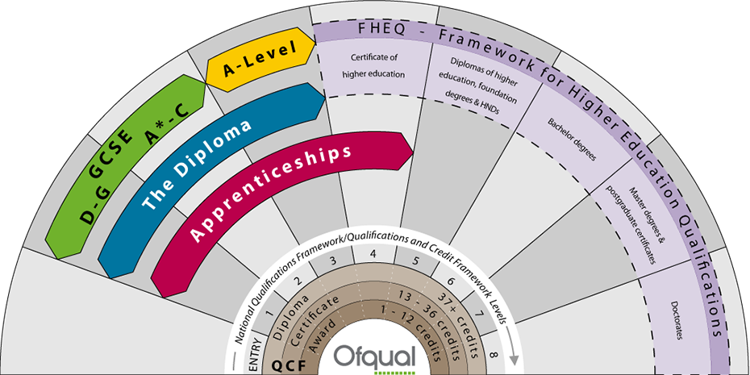

For information regarding equivalence between UK (incl. Scotland) and Ireland please see the Qfqual document Guide to comparing Qualifications in the UK and Ireland available at http://ofqual.gov.uk/help-and-advice/comparing-qualifications/

Section C National Awarding Organisations

Awarding organisations in the UK are regulated by the following organisations:

Regulator What they regulate
Ofqual General and vocational qualifications in England and Northern Ireland https://www.gov.uk/government/organisations/ofqual

Welsh Assembly Government General and vocational qualifications in Wales https://www.gov.wales/education-skills

SQA Accreditation General and vocational qualifications in Scotland https://accreditation.sqa.org.uk/accreditation/home

CCEA General qualifications in Northern Ireland www.ccea.org.uk

Classifying types of education appropriate for accreditation by a regulated awarding body

Accredited educational programmes typically fall into two groups, those that appear in one of the national qualification frameworks and those that do not. The latter are frequently termed customised provision. In the case of customised provision the accreditation process is not concerned with the course content any further than:

- assessing if a level is attributed, it is the correct level and

- assessing that the course material is factually correct within the limits of their own expertise.

The process of mapping the content against any relevant industry standards is not part of the accreditation process. Awarding organisations are only concerned in ensuring the quality control of delivery and that assessment of the programme meets the required academic rigour.

Awarding organisations commonly engage in both national framework provision and customised provision. Despite being quite distinct categories the two are frequently confused by people not closely involved in this area of education provision.

Section D Continuing Professional Development (CPD)

The RCVS (Royal College of Veterinary Surgeons) defines CPD as “the systematic maintenance, improvement and broadening of knowledge and skills and the development of personal qualities necessary for the execution of professional and technical duties ”.

The ABTC considers it to be imperative that those involved in the teaching and assessment of units/programmes are informed of current theory and practice both relating to the subject matter they teach/assess and to teaching and assessment methods. Thus, to maintain standards it is expected that they would be able to show that appropriate CPD has been undertaken annually. CPD can take a variety of formats and the following is not an exhaustive list but appropriate activities may include:

- Attending organised courses, lectures or seminars/conferences
  - Shadowing someone or being mentored/peer reviewed
  - Participating in ‘learning sets’ - informal networks of colleagues who learn together, for example, by comparing and discussing programme structure/assessment/best practice/clinical cases
  - In-house training
  - Critical reading of journals and other relevant publications - keeping a reading diary/notes
  - Research, including research in preparation for giving lectures/seminars/presentations
  - Participating and contributing to a research project
  - Writing eg articles, book reviews, books (relevant to professional practice)
  - Studying for further relevant qualifications

