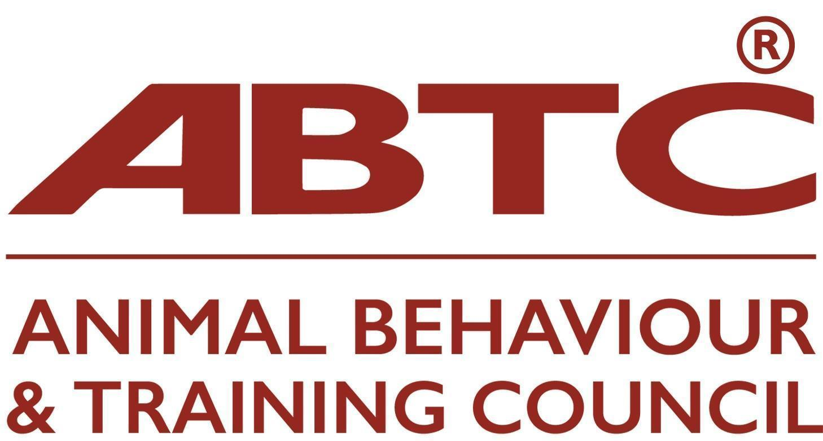 | Membership Application Form  Stage Two  Practitioner and Assessing Organisations

This application form is for Organisations that assess or represent practitioners in animal training or behaviour therapy and who are seeking to join the ABTC and enter their practitioner members onto the ABTC National Registers of Practitioners (Practitioner Organisation) or are applying for accreditation of their assessment process who have had Stage One accepted. Acceptance of an Organisation’s members onto the Registers is dependent upon demonstration that the Organisation’s:

- practitioner membership criteria match the agreed ABTC standard for the given practitioner register(s) applied for;
- methods of practitioner assessment are transparent and equitable;
Please see Guidance Notes for Practitioner Organisation or Assessing Organisation Application to assist in completing your application. The potential outcomes of your application are listed in the Guidance Notes.

Organisation
Name of Organisation
Website address
Contact person (ABTC representative) |  | Email

Register/Assessment
Practitioner Register(s) applied for
Animal (insert species) Trainer |  | Animal Behaviour Technician
Animal ( insert species) Training Instructor |  | Clinical Animal Behaviourist
 |  | Veterinary Behaviour Specialist
ABTC Code of Professional Conduct
Do practitioners sign/agree to ABTC’s Code of Professional Conduct – Yes/No
If yes, how is this achieved?
Organisations mechanism for monitoring and discipling practitioners’ compliance with the above code

Attachments
Please list the electronic attachments included in respect of the organisation’s assessment methods and application/reporting form. Please remember to include the completed ABTC checklist.

Signature
Date:
Full name and role in your organisation:

Please ensure all sections of the form are completed rather than referring to your website or other documents.

On acceptance, an annual membership fee of £280.00 becomes payable (pro rata to bring in line with the Animal Behaviour and Training Council’s fiscal year). An invoice will be sent

Please return this form to the ABTC Secretariat, email: assessments@abtc.org.uk

