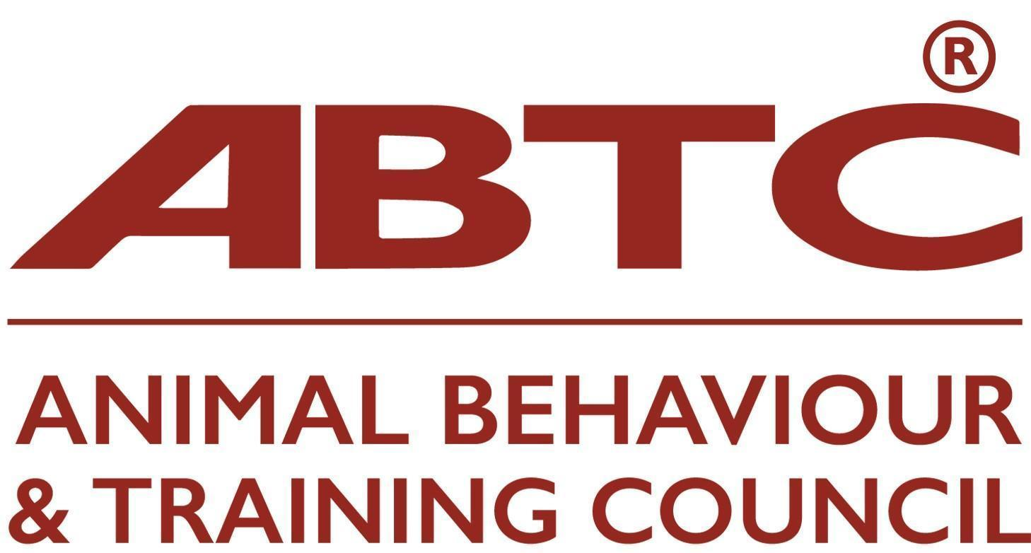 | Membership Application Form  Stage Three  Assessing Organisations

This application form is for Organisations that assess practitioners in animal training or behaviour therapy and who are seeking to join the ABTC and assess practitioners to the role standards of the ABTC. Acceptance of an Organisation’s assessed practitioners is dependent upon demonstration that the Organisation:

Please see Guidance Notes for Assessing Organisation Application to assist in completing your application. The potential outcomes of your application are listed in the Guidance Notes.

Organisation
Name of Organisation
Contact person (ABTC representative) |  | email

Assessment roles
Practitioner role assessments (s) applied for
Animal (insert species) Trainer |  | Animal Behaviour Technician
Animal (insert species) Training instructor |  | Clinical Animal Behaviourist
Please complete the appropriate Appendices to this application form to detail how the Organisations’ assessment criteria match the agreed ABTC standards for the practitioner role(s) applied for.

Attachments
Please list the electronic attachments included in respect of the organisation’s procedures and protocols.

Signature
Date:
Full name and role in your organisation:

Please ensure all sections of the form are completed rather than referring to your website or other documents.

On acceptance, an annual membership fee of £280.00 becomes payable (pro rata to bring in line with the Animal Behaviour and Training Council’s fiscal year).

Please return form to Secretariat on email: assessments@abtc.org.uk

Please transfer your membership fee to:

Animal Behaviour & Training Council
Sort code: 30-92-79
Account no. 28617368

Please include reference to the name of your organisation and send remittance advice to treasurer@abtc.org.uk

Or send a cheque to: Animal Behaviour and Training Council, c/o Milsted Langdon, Winchester House, Deane Gate Avenue, Taunton, TA1 3UH

