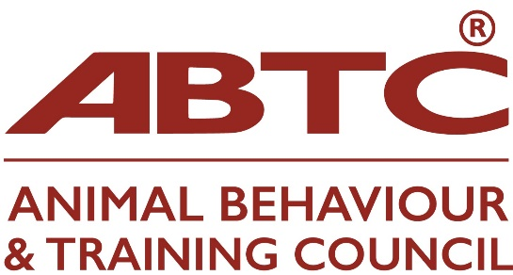

APEL Q&A

Please find below a zoom invitation to the ABTC APEL Q&A zoom meeting on Wednesday, 7 January 2026 at 7.00pm

NB This meeting will be recorded and the recording will be shared on the ABTC website

Topic: APEL Q&A

Time: Jan 7, 2026 07:00 PM London
Join Zoom Meeting
https://us02web.zoom.us/j/83586040867?pwd=arXVEMm73udIyuG5IcfzpbSrzK0ZyH.1

Meeting ID: 835 8604 0867
Passcode: 578387

