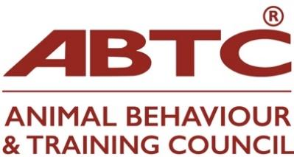

ABTC Programme Recognition: Unit Outline Form

A separate form must be completed for each Unit.

Learning Provider:

Programme Contact’s Name as per application form:

Date:

1 Unit title

2 Unit code

3 Credit rating

4 Level (stated as per National Qualifications level, eg HE1 or HE3)

5 Any pre-requisite and/or co-requisite units

6 Programmes in which the unit is situated

7 Unit co-ordinator

8 Aims and learning outcomes

Aims

Knowlege & Understanding (K&U) Learning outcomes
By the end of this unit students will be able to:

- Curricular content

10 Teaching and learning methods

11 Contact hours

12 Non-contact hours

13 Total study time

14 Assessment methods

15 Assessment requirements and weighting to final grade

Assignment 1 :

This assignment will assess K&U learning outcome

Assignment 2 :

This assignment will assess K&U learning outcome

All assignments are compulsory and all must be passed/Passing of assignments (assignment number) is not compulsory*
*(delete as necessary)

Assignment rationale:

Teachers and subject area

Subject area | K&U Learning outcomes | Lecturer | Number of contact hours | Teaching format
Assignment |  | First & second marker (moderator)

