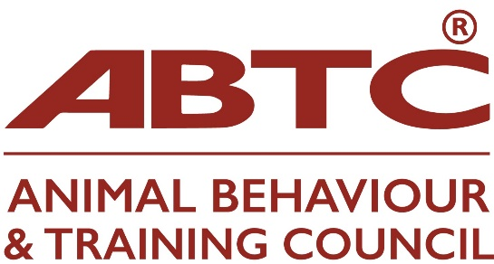

APEL Q&A

Please find below a zoom invitation to the ABTC APEL Q&A zoom meeting on Wednesday, 5 November 2025 at 7.00pm

NB This meeting will be recorded and shared on the website

Topic: APEL Q&A
Time: Nov 5, 2025 07:00 PM London

Join Zoom Meeting
https://us02web.zoom.us/j/88607545025?pwd=wpeeCCugtqwscnGZRdcC8u2FufShi3.1

Meeting ID: 886 0754 5025
Passcode: 966585

