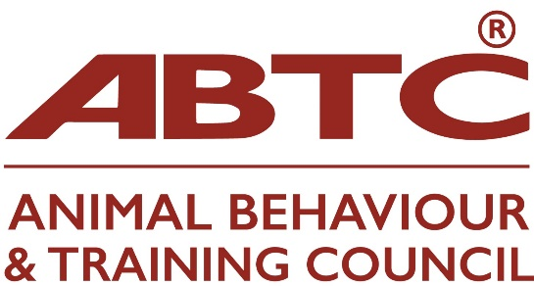

**APEL Q&A**

**Please find below a zoom invitation to the ABTC APEL Q&A zoom meeting on Wednesday, 15 January 2025 at 7.00pm**

Topic: APEL Q&A

Time: Jan 15, 2025 07:00 PM London

Join Zoom Meeting

<https://us02web.zoom.us/j/86382824031?pwd=RZsKbPCvLobjJLR4vHY0T16z5csnYL.1>

Meeting ID: 863 8282 4031

Passcode: 310999

**NB This meeting will be recorded and shared on the website**