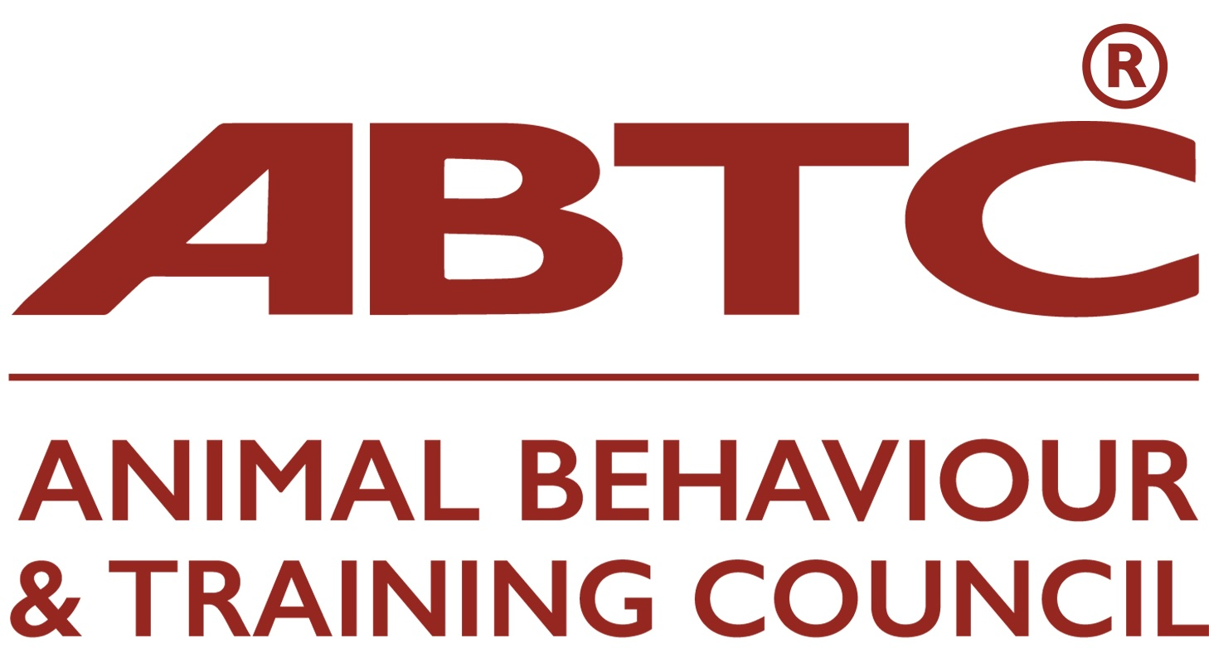

Application for ABTC Recognition of Programme: CV Proforma for Staff involved in Teaching and/or Assessment

Please complete ALL sections (A-F) stating Not Applicable as relevant.
Please provide copies of supporting documentation such as qualification and CPD certificates

- Contact Details

Name:

Address:

Country:

Phone:

E-mail:

- Area of teaching responsibility on the programme (module, subjects and/or LO number):

- Academic Qualifications including any teacher training / mentoring qualifications

Subject | Institution | Date of qualification | A-Level | Degree | Postgraduate

- Practical / Industrial qualifications e.g. BHS or BIPDT. Please give level attained

Qualification name | level | Institution | Date obtained

- Industry Experience
Please provide a brief overview of your relevant industry experience: how long you have worked in the field, in what type of establishment, and roles undertaken.

- Continuing Professional Development (CPD)

CPD attended in the last three years: This should include CPD both external to and within the Learning Provider organisation

CPD subject | Organising body | Length (hours) | Date

- Oral Presentations

Please list oral presentations given external to this Learning Provider Organisation in the last three years, e.g. conference

Title of presentation | Event / audience | date

- Publications

Please list relevant publications

- Peer-Reviewed Publications (e.g. in Peer reviewed journals)

- Non-Peer reviewed Publications (including audio-visual productions)

- Criminal Convictions

I confirm I have no criminal convictions that are relevant to me owning or working with animals or with vulnerable people, including children and older adults.

(where appropriate, please include copy of Disclosure and Barring Service Check).

Signature Date

- Declaration

To the best of my knowledge the information given herein is correct and I agree to abide by the ABTC Code of Practice with respect to my teaching and practice.

Signature Date

