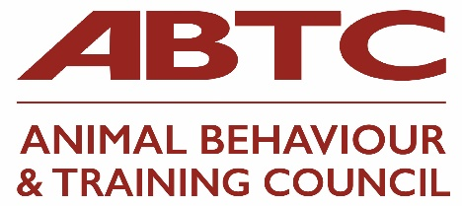 | Application Form  ABTC Advocate

Animal Behaviour and Training Council Advocate status is open to all veterinary practices in the UK.

Criteria for membership are:
- The organisation must be of good standing and is committed to the aims of the ABTC
- The organisation must also support and align their actions with the charitable aims of the ABTC
'To promote humane practice in the training and behaviour therapy of animals and; to lobby for improvements in animal welfare related to behaviour and training of said animals'

Advocates do not have voting rights in respect of ABTC business or the right to attend Council Meetings. It will suit veterinary practices that wish to make their support of the Council known.

Name of Practice
Website address
Contact person |  | Email
Telephone
Postal address
Second contact |  | Email
Telephone

Practice structure (branches / corporate links)
How many staff do you have in your practice/branches?
Practice’s Mission Statement and Code of Conduct/Practice/Ethics employees conduct with animals and clients

Current protocols for referring behaviour cases and recommending trainers/instructors

Signature | Date

Please ensure all sections of the form are completed rather than referring to your website or other documents.

On acceptance, an annual fee of £75.00 becomes payable
Please return form to admin@abtc.org.uk

Please transfer your fee to:
Animal Behaviour & Training Council
Sort code: 30-92-79
Account no. 28617368

Include reference to the name of your organisation

Please send remittance advice to treasurer@abtc.org.uk

Or send a cheque to:
Animal Behaviour and Training Council
The Warren, Kellaways, Chippenham, Wiltshire SN15 4LR

https://abtc.org.uk/

