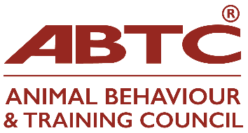
Skills-audit and application to join the ABTC Board of Trustees

Name:
If you are interested in joining ABTC’s Board of Trustees, would you please detail experience of any of the below.

Applications must be received by 19 April 2024, please
Skill/Experience/Knowledge | Tick/ check | Details
Accountancy
Animal welfare
Animal practitioner
Assessing
Business Management
Campaigning
Charity Trustee
DEI Work / lived experience
Education
Electronic communication
Event organisation
Fundraising
Human Resources
Legal
Marketing
Media/PR
Social media
Veterinary

Do you have anything you wish to contribute to the Board of Trustees not mentioned above either in terms of experience, knowledge or skills?

Please feel free to attach further notes or a CV detailing your experience.

Please also include a short note as to why you would like to join the Board of Trustees and if you have any particular areas of interest. These will all be shared with ABTC Members for voting purposes.

Signed:
Date:
Once completed, please return your application to admin@abtc.org.uk
no later than 19 April 2024

