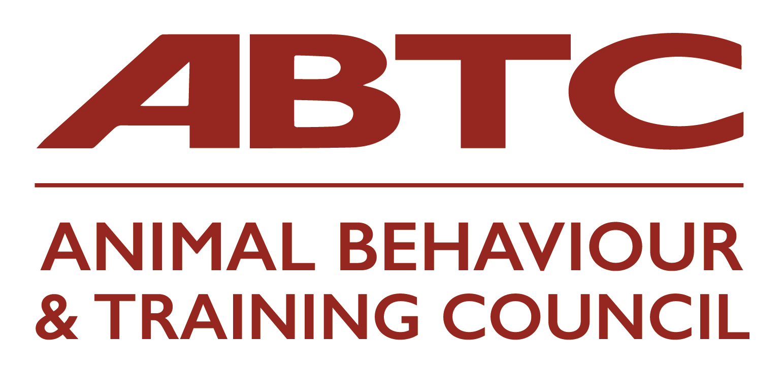 | Practitioner Organisations’  Application Form  Part One

This application form is for Organisations that represent practitioners in animal training or behaviour therapy and who are seeking to join the ABTC and enter their practitioner members onto the ABTC National Registers of Practitioners. Acceptance of an Organisation’s members onto the Registers is dependent upon demonstration that the Organisation’s:

- Code of Conduct is appropriate and sufficiently well policed to ensure that practitioner standards of practice fall within those required by the ABTC;
- practitioner membership criteria match the agreed ABTC standard for the given practitioner register(s) applied for;
- methods of practitioner assessment are transparent and equitable;
- monitoring of practitioners’ on-going compliance with the ABTC standards is effective.
Please see Guidance Notes for Practitioner Organisation Application to assist in completing your application. The potential outcomes of your application are listed in the Guidance Notes.

Box 1
Name of Organisation
Website address
Postal address
Contact person (ABTC representative) |  | email
Telephone
Second contact |  | email
Telephone

Box 2
Practitioner Register(s) applied for
Animal – (insert species) trainer |  | Animal Behaviour Technician
Animal – (insert species) training instructor |  | Clinical animal behaviourist
 |  | Veterinary behaviour specialist

Box 3
Organisation’s Code of Conduct / Practice / Ethics for practitioner members

Organisation’s mechanism for monitoring and disciplining practitioners’ compliance with above Code

Organisation’s GDPR policy/compliance

Box 4
Organisation’s requirements for practitioner continuing professional development (CPD)

Organisation’s mechanism for monitoring and disciplining practitioners’ compliance with CPD requirements

Box 5
Please list the electronic attachments included in respect of the organisation’s procedures and protocols.

Signature
Date:
Full name and role in your organisation:

Once the above has been checked, and accepted, by ABTC you will be sent the paperwork to proceed to the second part of the application which looks at the details of your assessment process for practitioners.

Please ensure all sections of the form are completed rather than referring to your website or other documents.

Applications should be accompanied by a non-refundable application fee of £50.00.

On acceptance, an annual membership fee of £250.00 becomes payable (pro rata to bring in line with the Animal Behaviour and Training Council’s fiscal year).

Please return to the ABTC Secretariat  Email: admin@abtc.org.uk  Animal Behaviour and Training Council  c/o Milsted Langdon  Winchester House  Deane Gate Avenue  Taunton  TA1 3UH | Please transfer your fee to:  Animal Behaviour & Training Council  Sort code: 30-92-79  Account no. 28617368  Include reference to the name of your organisation.  Please send remittance advice to treasurer@abtc.org.uk  Or send a cheque to the address opposite

