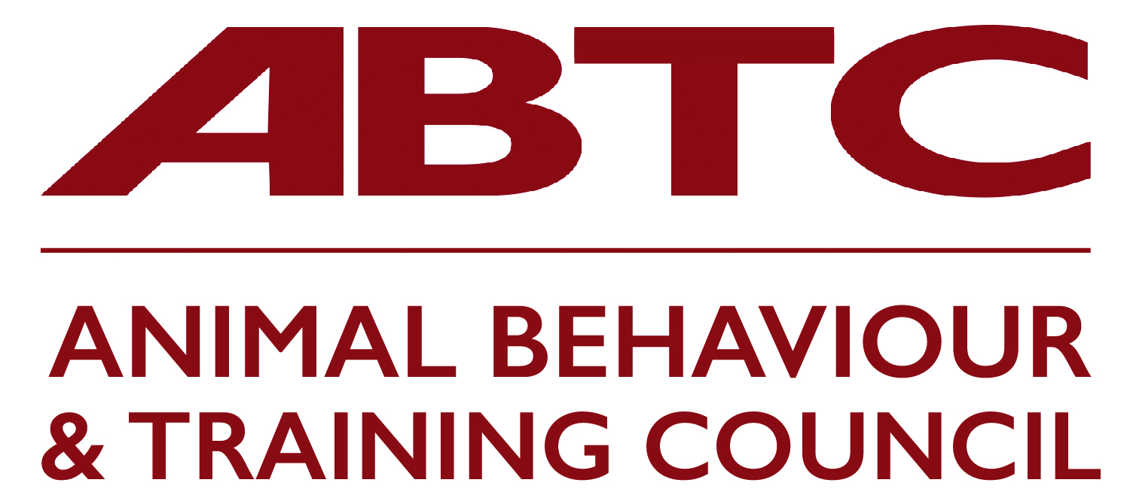 | Membership Application Form  Supporting Membership

Animal Behaviour and Training Council membership is open to all professional organisations with a stake in the behaviour and training/behaviour therapy of animals kept in association with humans in the UK.

Supporting membership is open to professional groups that are in some way involved with animal welfare but do not directly represent practitioners involved in delivering animal training or animal behaviour therapy eg charitable organisations. Criteria for membership are:
- The organisation must be of good standing and is committed to the aims of the ABTC
- The organisation is required to have an approved Code of Conduct/Practice/Ethics to which all their members adhere and to actively support the aims of the ABTC.

Supporting organisation membership is similar to Advisory organisation membership with the exception that they do not have voting rights. It will suit organisations that wish to make their support of the Council known, they will still be able to take an active part in discussions and consultations.

Organisations that represent practitioner members, who on joining the Council may enter their members on the ABTC National Registers of animal trainers and behaviour therapists, need to complete the Practitioner Organisations’ application from to additionally apply for accreditation of their practitioner membership criteria against the agreed standards for the category/categories of practitioner their members fall under.

Name of organisation
Website address
Contact person (ABTC representative) |  | Email
Telephone
Postal address
Second contact |  | Email
Telephone

Brief history of organisation
Organisation’s membership structure and numbers
Organisation’s Mission Statement and Code of Conduct/Practice/Ethics for members/employees conduct with animals and clients

Evidence of organsation’s commitment to the aims of the ABTC

Any supporting statements that may enhance the application

Signature | Date

Please ensure all sections of the form are completed rather than referring to your website or other documents.

Should any of the above items require attention in order to meet the Animal Behaviour and Training Council’s requirements, provisional membership may be granted for a limited period whilst such a situation is addressed.

On acceptance, an annual membership fee of £75.00 becomes payable (pro rata to bring in line with the Council’s fiscal year).

Please return to admin@abtc.org.uk  Animal Behaviour and Training Council  c/o Milsted Langdon  Winchester House  Deane Gate Avenue  Taunton  TA1 3UH | Please transfer your fee to:  Animal Behaviour & Training Council  Sort code: 30-92-79  Account no. 28617368  Include reference to the name of your organisation  Please send remittance advice to treasurer@abtc.org.uk  Or send a cheque to the address opposite

